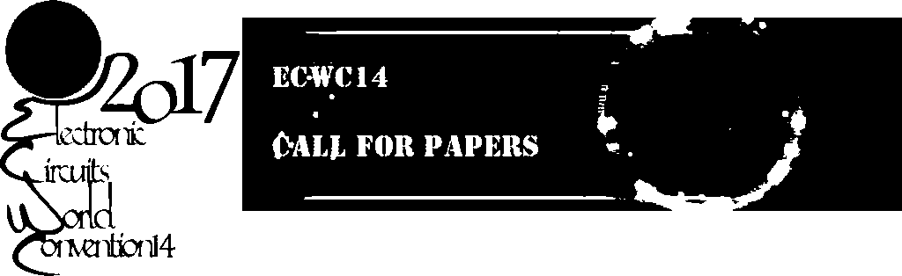

14th Electronic Circuits World Convention

KINTEX, South Korea April 25~27, 2017
The 14th Electronic Circuits World Convention will be held in KINTEX, Goyang City, S. Korea from April 25 to April 27, 2017 along with KPCAshow hosted by Korea Printed Circuits Association (KPCA) as well as World Electronic Circuits Council (WECC). This premier international conference is a triennial event for a world-class gathering of professionals from academia, industry and government, providing a forum to exchange ideas and recent developments in various fields of electronic interconnection and fostering networking and collaborations.

Topics
The ECWC14 invites submission of abstracts on a wide range of topics, spanning both business and technical topics. The topics of interest include, but not limited to:
-Management

M1 Market Trends and Outlook
Global or Regional Market of PCB, Materials, equipment, packaging, assembly and end products

M2 Supply Chain Management (SCM)
Inventory Management, Contact Electronic Manufacturing services, Outsourcing , Supply Chain Collaboration, and Supply Chain Risk Management .

M3 Standard, Certification and Qualifications
IEC/ISO, UL, Third Party Quality assessment, standard and product certification

M4 Environment, Health and Safety (EHS)
Environmental registration, halogen-free, lead-free, Incorporating green technology

M5 Business Strategy

-Technology
T1 Materials and Components
New material on board manufacturing and packaging, New components for SMT and
assembly
T2 Design and Data Transfer
T3 Test and Reliability
T4 PCB Processes, Chemical and Physical
T5 HDI / Fine Circuit Fabrication, Processes and Equipment
T6 Flexible Circuit
T7 Application Specific Circuits
Wearable, IoT, Automobile, High Power, High Speed, LED and Energy
T8 Packaging/Substrate Technology
T9 SMT and Assembly
T10 Emerging Technologies
Printed electronics, Device Embedded Substrate, FOWLP, 3D circuit

Please visit ECWC section on KPCA's English web site
(http://www.kpca.or.kr/kr/eng/main.php) to submit the abstract and get the details. Meanwhile, the abstract is welcomed and should be put forward to inter@cpca.org.cn at the attention to Elaine Chan before Sept.30, 2016.
Session Formats
The ECWC14 is interested in papers as well as posters
Important Dates
Opening of abstract submission
29th June 2016
Abstract submission deadline
30th September 2016
Notification of Abstract acceptance
31th October 2016
Full paper submission deadline
28th February
2017 Early Registration deadline
18th March 2017
Contact
For more information about ECWC 14, please contact Dr. Tim Lee, ECWC14 Secretariat, at mslee@kpca.or.kr

